# C:\Users\Yavuz\AppData\Local\Microsoft\Windows\INetCache\Content.MSO\CB346969.tmp

# Circuit Theory 1

# Fundamental of Electronics

## **Homework 3**

**Student Name :** BARIS

**Student Surname :** KARAPELIT

**Student Number :** 21707346

Circuit 1, HW3

Find *I* in the circuit below

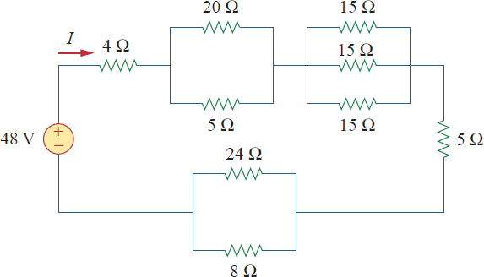



Parallel to: Series to:

REQ= REQ=R1+R2+R3+……

a to :

aeq = = = 4 Ω REQ= 4 + a + b + 5 + c

= 4 + 4 + 5 + 5 + 6

b to : REQ= 24 Ω

beq = = = 5 Ω V = I.R

c to : I = $\frac{V}{R}$

I = $\frac{48}{24}$

ceq = = = 6 Ω I = 2 A